THE WHITNEY MUSEUM CELEBRATES 10 YEARS DOWNTOWN WITH 10 WEEKS OF PUBLIC PROGRAMS AND EVENTS BEGINNING MAY 1

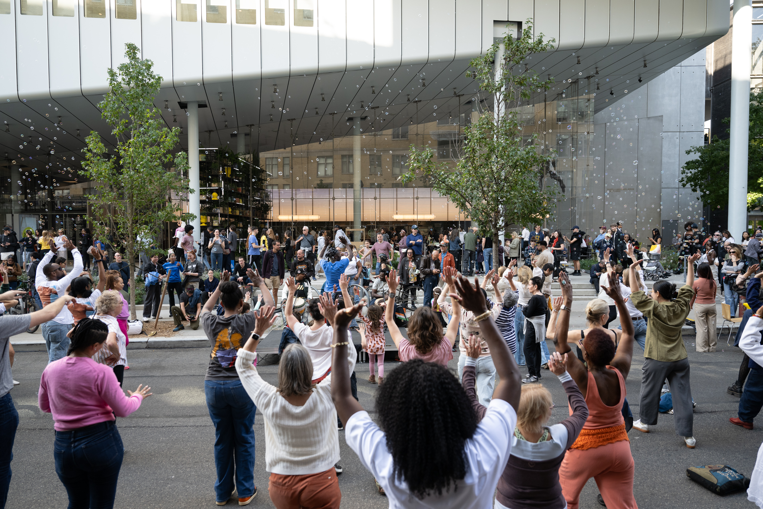

Celebrate the Whitney’s “Decade Downtown” with dance parties, live music, DJ nights, tours, artmaking activities, and more!

New York, NY, March 25, 2025 — The Whitney Museum of American Art presents Decade Downtown, a series of on-site public programs and events spanning ten weeks, starting in May 2025 and running through mid-July to celebrate ten years of the Whitney in the Meatpacking District. Since May 2015, the Museum has called this neighborhood home in its Renzo Piano– designed building at 99 Gansevoort Street. As part of a neighborhood rich in history, creativity, and cultural exchange, the Whitney has played an integral role in contributing to this vibrant cultural center on Manhattan’s west side by bringing art, ideas, and community together with its state-of-the-art exhibitions, education programing, free admissions initiatives, and strong engagement with partner organizations and neighbors.
To mark this exciting milestone and celebrate many more years to come, Decade Downtown will activate the Museum building and surrounding neighborhood with festivities for visitors of all ages. Enjoy free admission during Free Friday Nights, from 5–10 pm each week, and Free Second Sundays each month. Also enjoy live music, dance parties, and DJ sets in the Museum lobby throughout the ten weeks. In the month of May, there will be a special pop-up Decade Downtown listening lounge presented by Public Records where visitors can kick back, relax, and enjoy time with friends and family on the Museum’s 7th floor. Artist-led programs, artmaking activities, and more will be available throughout the ten weeks of programming along with critically acclaimed exhibitions like Amy Sherald: American Sublime, opening April 9, Christine Sun Kim: All Day All Night, and Shifting Landscapes.

Decade Downtown also coincides with two beloved annual celebrations at the Whitney, Pride and West Side Fest. Whitney Pride activities will run throughout the month of June and include performances by New York City Gay Men’s Chorus, queer history walking tours of the Meatpacking District, and much more. These free public programs and events are dedicated to LGBTQ+ artists and communities and offer an inclusive space for all to gather and enjoy American art. In July, Decade Downtown will culminate with West Side Fest, a three-day festival from July 11–13 organized by the West Side Cultural Network—a group of museums, parks, performing arts centers, and cultural institutions located within a half-mile portion of historic New York. Visitors of all ages are invited to celebrate the vibrant, cultural village along the waterfront of Manhattan’s west side.

More information about Decade Downtown and updated program information is available on the Whitney’s website at whitney.org/decade-downtown.

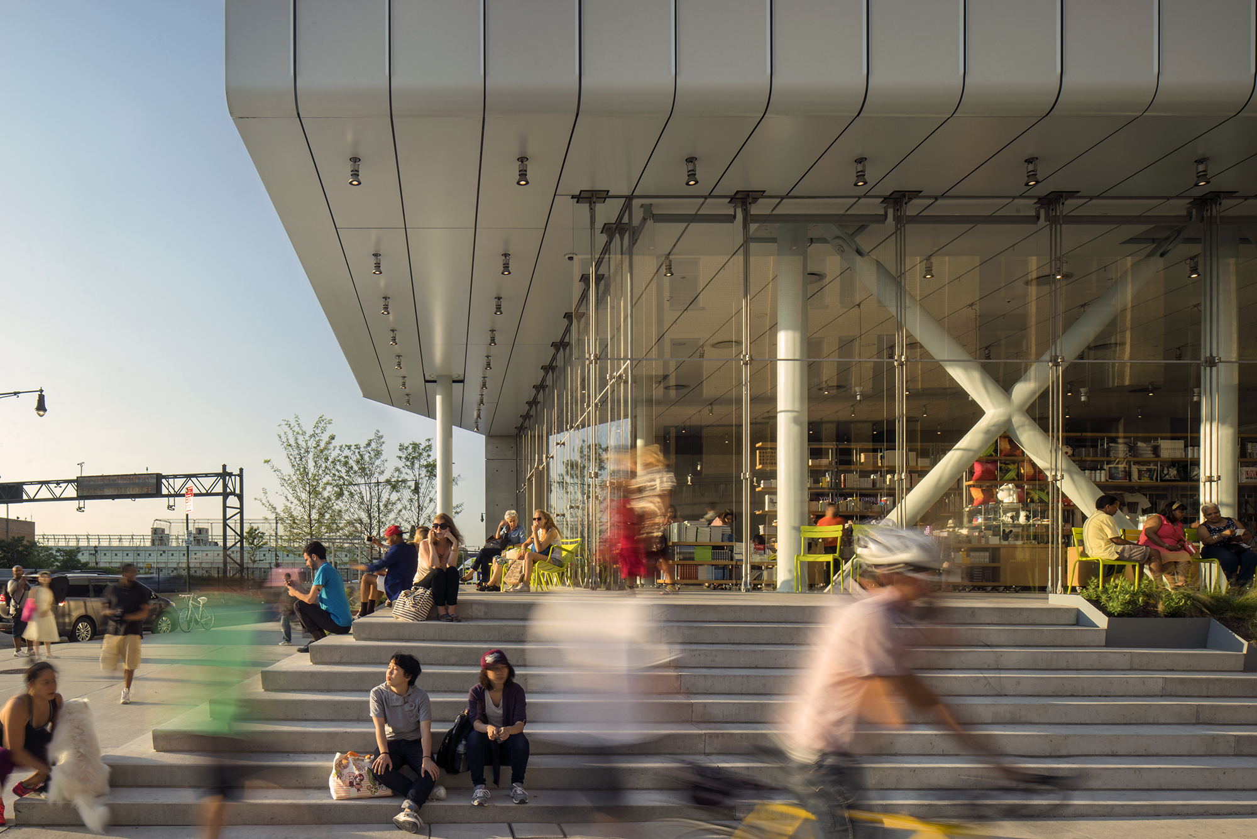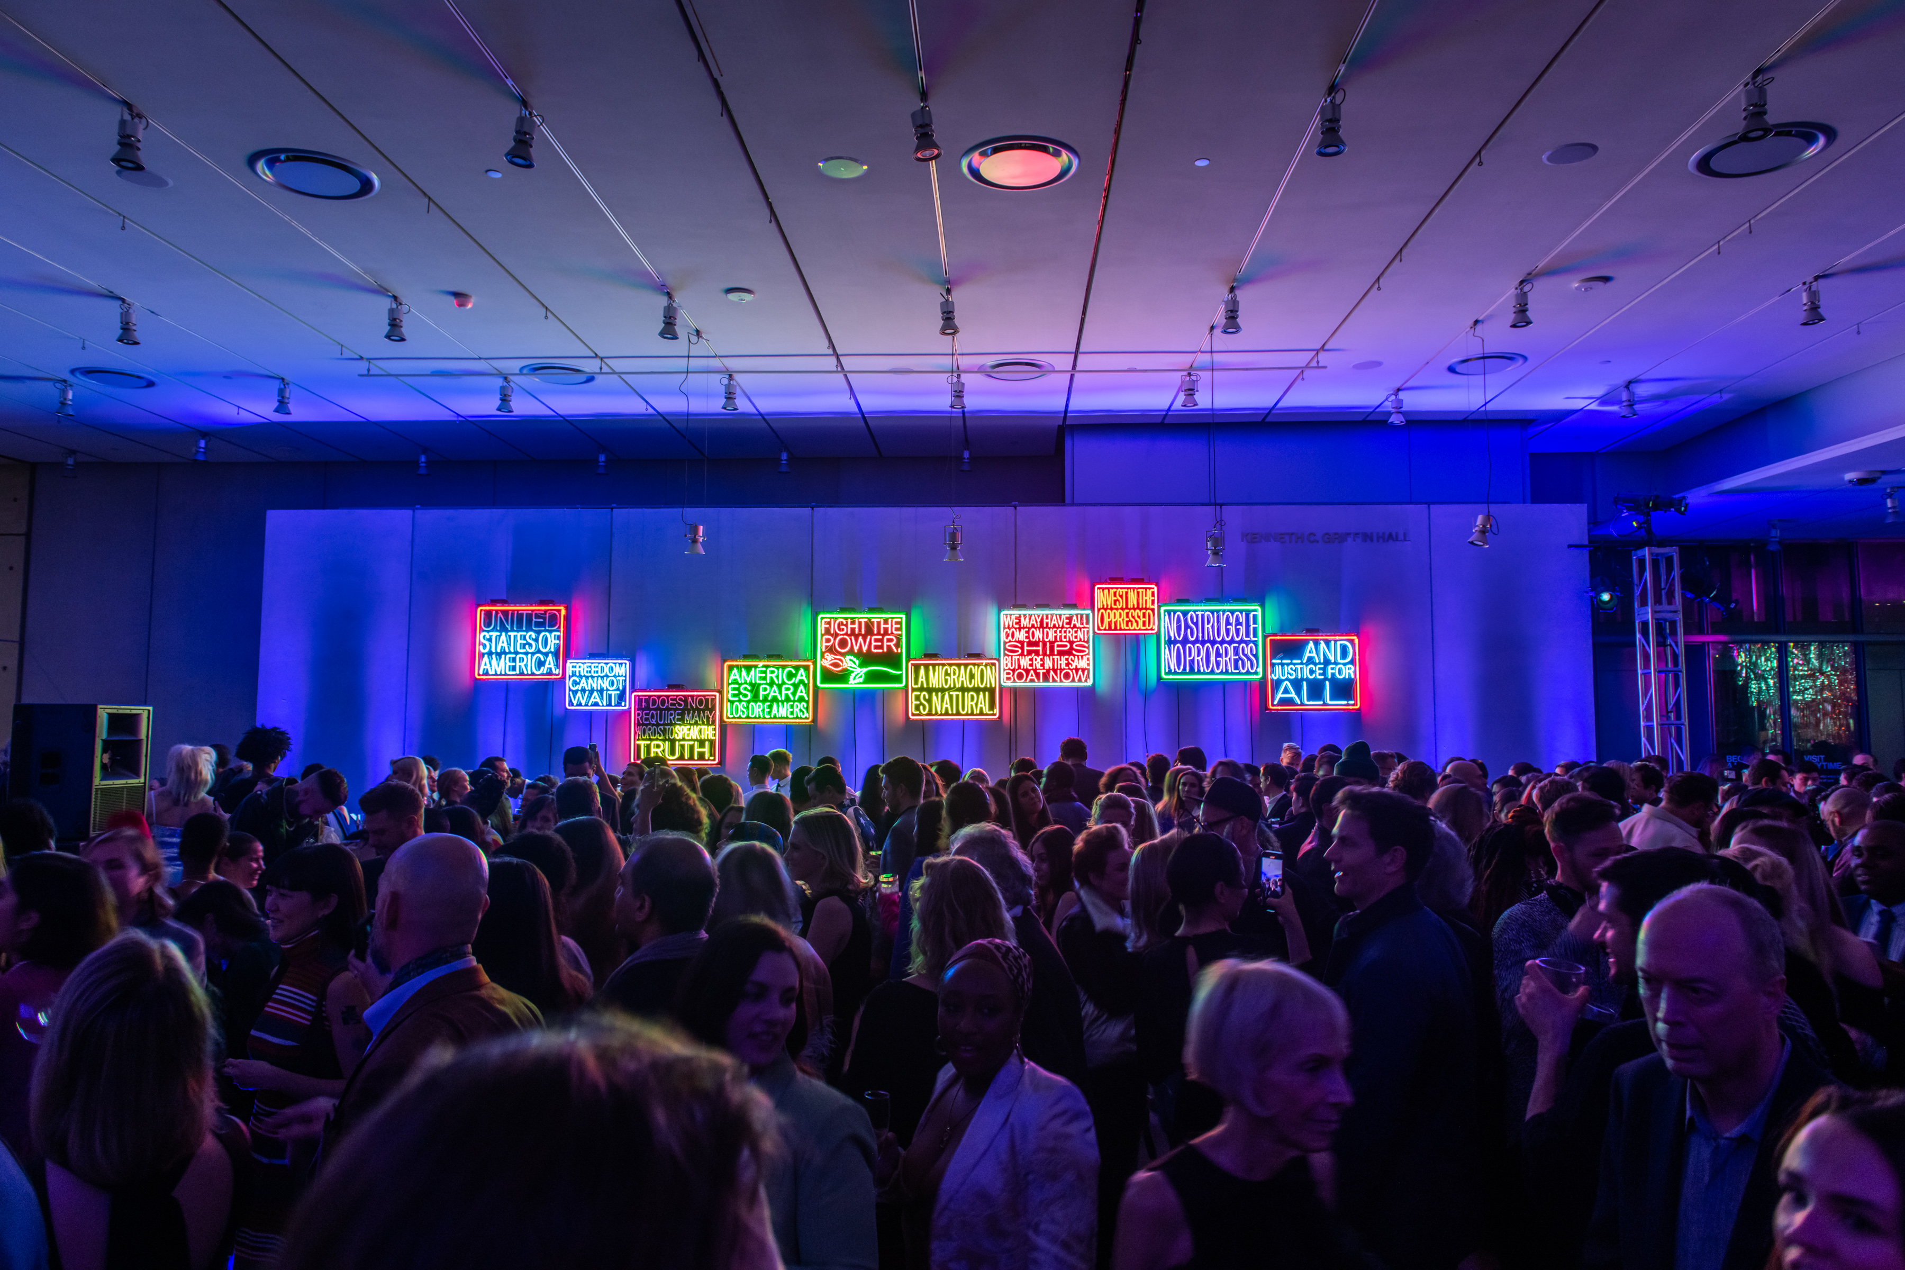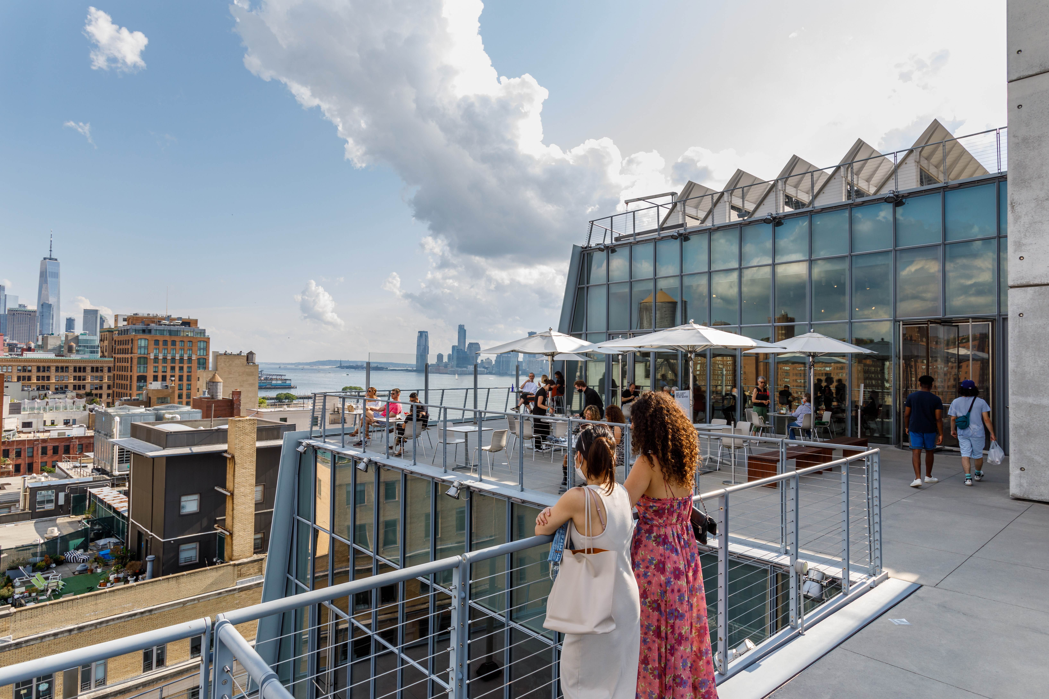

PROGRAM LISTINGS

Tickets to the Museum must be reserved separately, including on Free Friday Nights and Free Second Sundays. Advance booking is recommended.
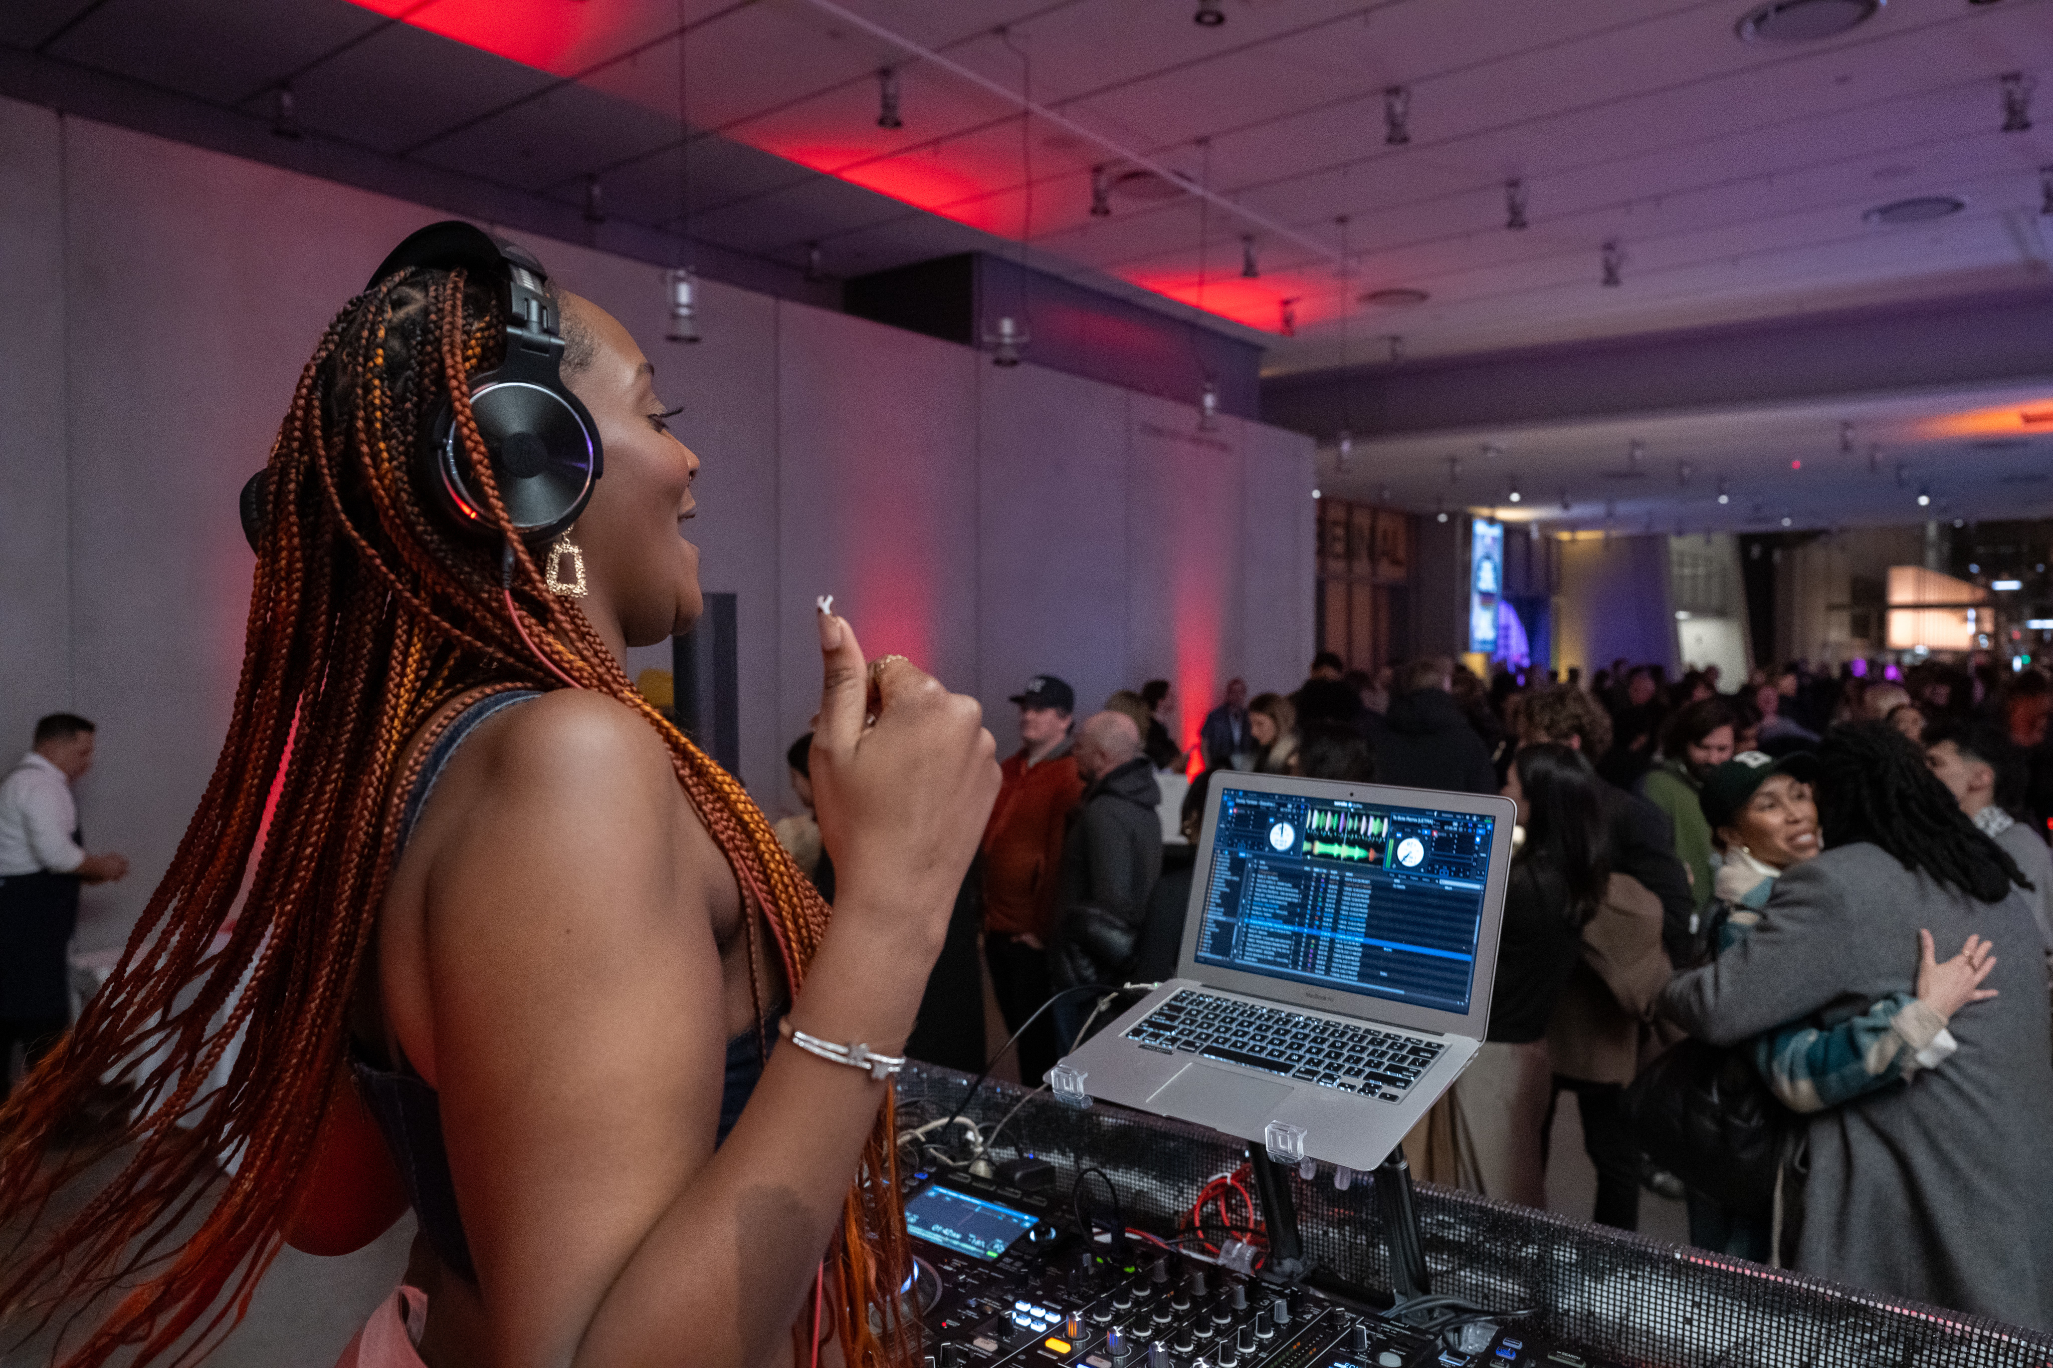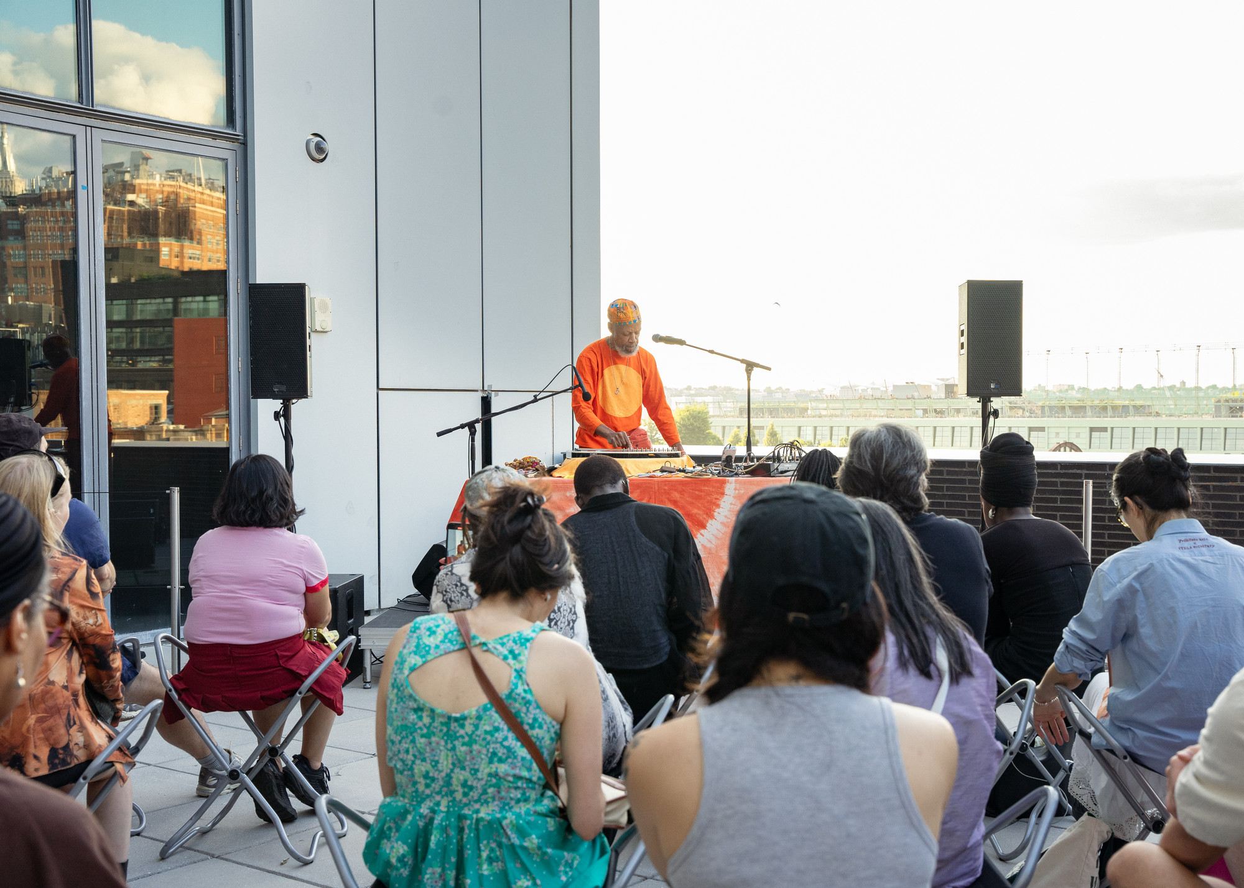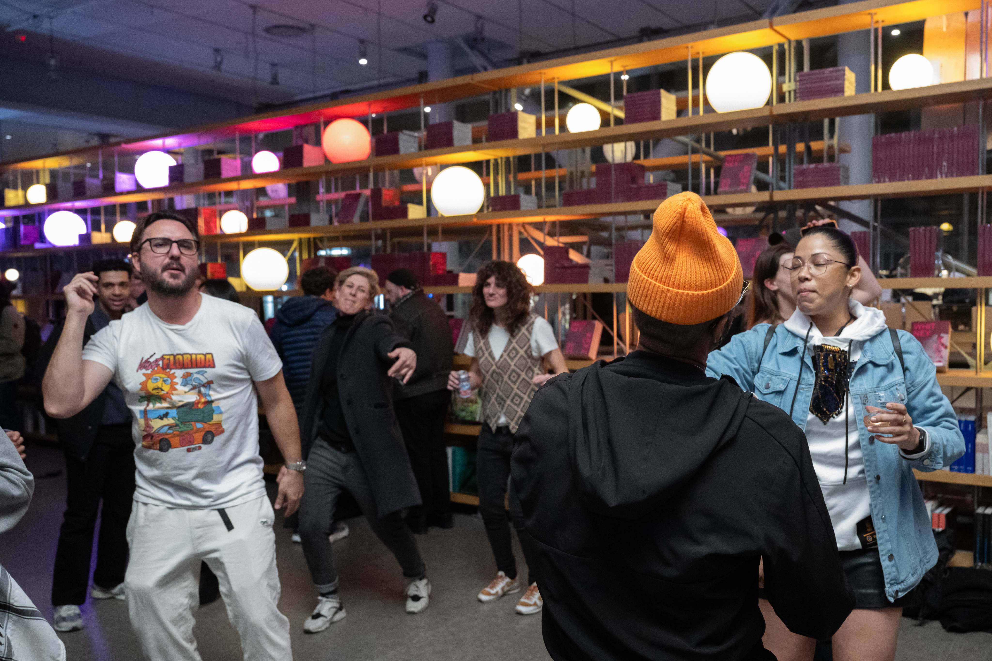

May

Decade Downtown Kickoff Celebration
Thursday, May 1, 7:30–10 pm

Kick off the Whitney’s Decade Downtown festivities with a vibrant party to remember! Celebrate ten years of the Whitney in the Meatpacking District—a decade of art, culture, and community—with an evening that honors the neighborhood’s creativity and cultural exchange alongside new spring exhibitions including Amy Sherald: American Sublime, Christine Sun Kim: All Day All Night, and Shifting Landscapes. Join us for music, artmaking, gallery tours, pop-up bars, neighborhood walking tours, and more!

Location: Whitney Museum
Tickets: Ticketed (1 Individual Ticket: $51 or 2 Individual Tickets + 1 Year of Membership $102). Whitney Members attend this special celebration for free with their membership card.
Event Link: https://whitney.org/events/member-night-decade-downtown

Decade Downtown Free Second Sunday
Sunday, May 11, 10:30 am–6 pm

On Sunday, May 11, the Whitney is offering free admission from 10:30 am–6 pm for visitors
of all ages. Celebrate the Whitney’s Decade Downtown with a trip down music history lane on the Museum’s 7th floor which will be transformed into a pop-up listening lounge presented by Public Records. Kick back with friends and family and listen to live performances and DJ sets featuring the music of some of your favorite artists who for decades have infused Whitney’s downtown neighborhood with creativity and innovation. Additional Second Sunday
programs include free story times with librarians from The New York Public Library in the
Museum’s lobby at 11 am, 1 pm, and 3 pm.

Location: Whitney Museum
Tickets: Free; Tickets are still required, and capacity is limited. Advance booking is strongly recommended and can be reserved at whitney.org/admission.
Event Link: https://whitney.org/decade-downtown

Embodying Eastman: Speculative Listening with Isaac Jean-François
Sunday, May 11, 1–2:30 pm

Join BlackBox Ensemble for an unforgettable afternoon of live performance. Based in New York, this contemporary music ensemble and creative laboratory is committed to experimentation, collaboration, and education.

To conclude the performance, there will be a brief Q&A session with Eastman Scholar Isaac Jean-François, moderated by Cris Scorza, Chair of Education.

Location: Whitney Museum, 7th Floor
Tickets: Free; Tickets are still required, and capacity is limited. Advance booking is strongly recommended and can be reserved at whitney.org/admission.
Event Link: https://whitney.org/events/fss-embodying-eastman-10

Decade Downtown DJ Set with Lovie and Honeybun
Sunday, May 11, 2:30–5:30 pm

Relax in our Decade Downtown pop-up listening lounge on the Whitney’s 7th floor and enjoy DJ sets by Lovie and Honeybun, both recognized as breakout DJ talents of 2024. Lovie’s eclectic sets blend house, techno, and global club sounds, creating an electrifying and unpredictable sonic journey, while Honeybun’s signature style fuses deep grooves, left-field electronic textures, and soulful beats, making each set a dynamic and immersive experience.

Location: Whitney Museum, 7th Floor
Tickets: Free; Tickets are still required, and capacity is limited. Advance booking is strongly recommended and can be reserved at whitney.org/admission.
Event Link: https://whitney.org/events/fss-decade-downtown-dj

Decade Downtown Dance Party with DJ Justin Strauss and Public Records
Friday, May 16, 5–10 pm

Celebrate the Whitney’s Decade Downtown and dance the night away on the Museum’s 7th floor which will be transformed into a pop-up listening lounge presented by Public Records. For this special edition of the Whitney’s Free Friday Nights, DJ Justin Strauss will pay tribute to the three decades of club music and culture that shaped New York’s downtown nightlife scene.

Since he was 17, when his first band was signed to Island Records, Justin Strauss has had a career that reads like a Who’s Who of the music scene, spinning at nearly every dance club that you’d ever want to go to. Starting as DJ at New York’s legendary Mudd Club, he spun his way through The Ritz, Limelight, Area, Tunnel, M.K., Life, Centro Fly, and more, pioneering his own distinctive sound, and becoming one of the most sought-after remixers and producers not just in New York, but in the world. He has worked with the gamut of artists—Depeche Mode, Sergio Mendez, Tina Turner, Jimmy Cliff, B-52s, Luther Vandross, Malcolm McClaren, Skinny Puppy, Goldfrapp, to name a few—and on over 200 records.

Location: Whitney Museum, 7th Floor
Tickets: Free; Tickets are still required, and capacity is limited. Advance booking is strongly recommended and can be reserved at whitney.org/admission.
Event Link: https://whitney.org/events/decade-downtown-dj-ffn

Decade Downtown Neighborhood Walking Tours
Thursday, May 1, 5 pm, 6 pm, 7 pm
Sunday, May 11, 12 pm, 4 pm
Friday, May 16, 6 pm
Friday, July 11, 6 pm
Sunday, July 13, 12 pm, 4 pm

The Whitney’s building may be new, but its surrounding neighborhood’s past is long and storied. From the many Greenwich Village artists who came through the Museum’s first home on 8th Street, to the varied artistic projects along the Hudson River Piers, the history of the Whitney brings together the creative communities that shaped it. Join a Whitney Museum Educator or Teaching Fellow to learn about the vibrant and varied cultural highlights within just a few blocks of the Whitney.

Location: Whitney Museum and Surrounding Neighborhood
Tickets: Free; Tickets are still required, and capacity is limited. Advance booking is strongly recommended. Tours will meet outside the entrance of the Museum and the meeting place will be marked with physical signage.
Event Link: https://whitney.org/events/whitney-walking-tour-decadedowntown

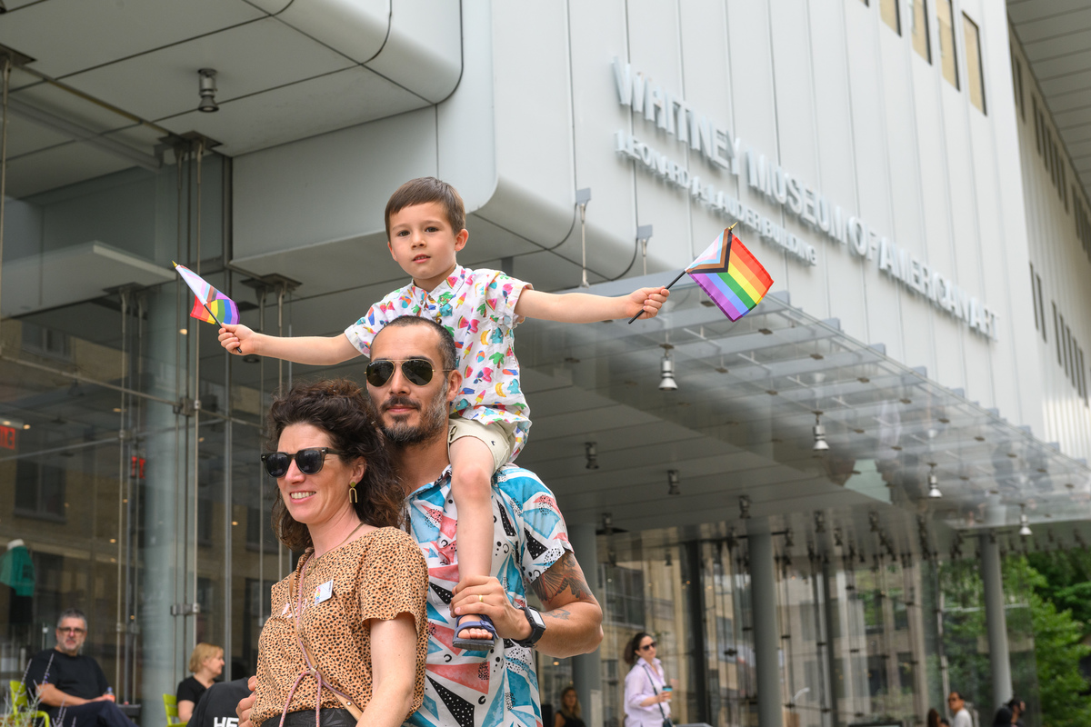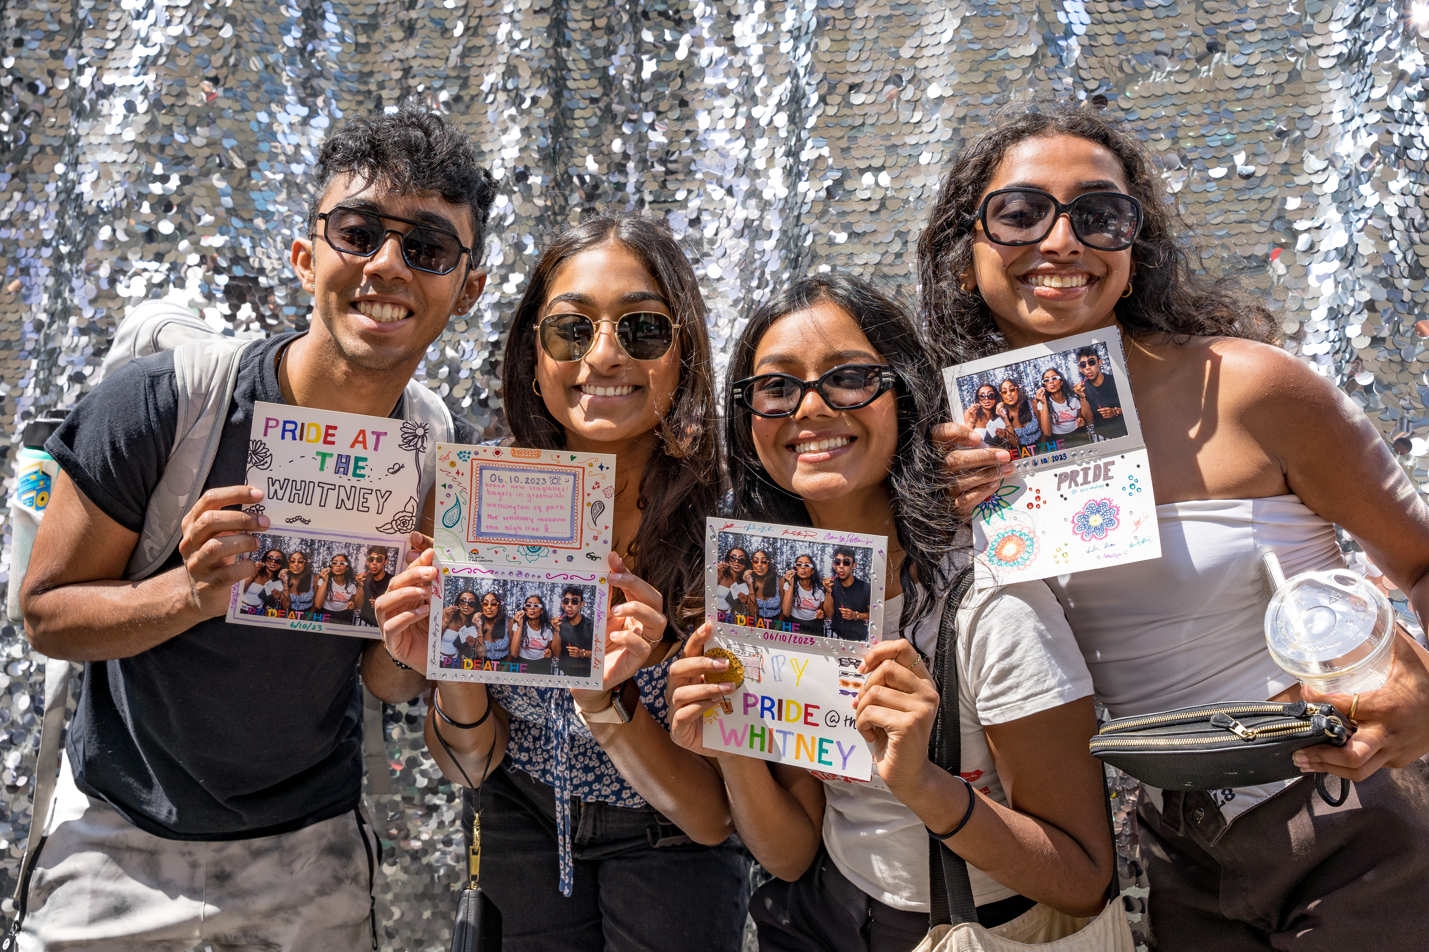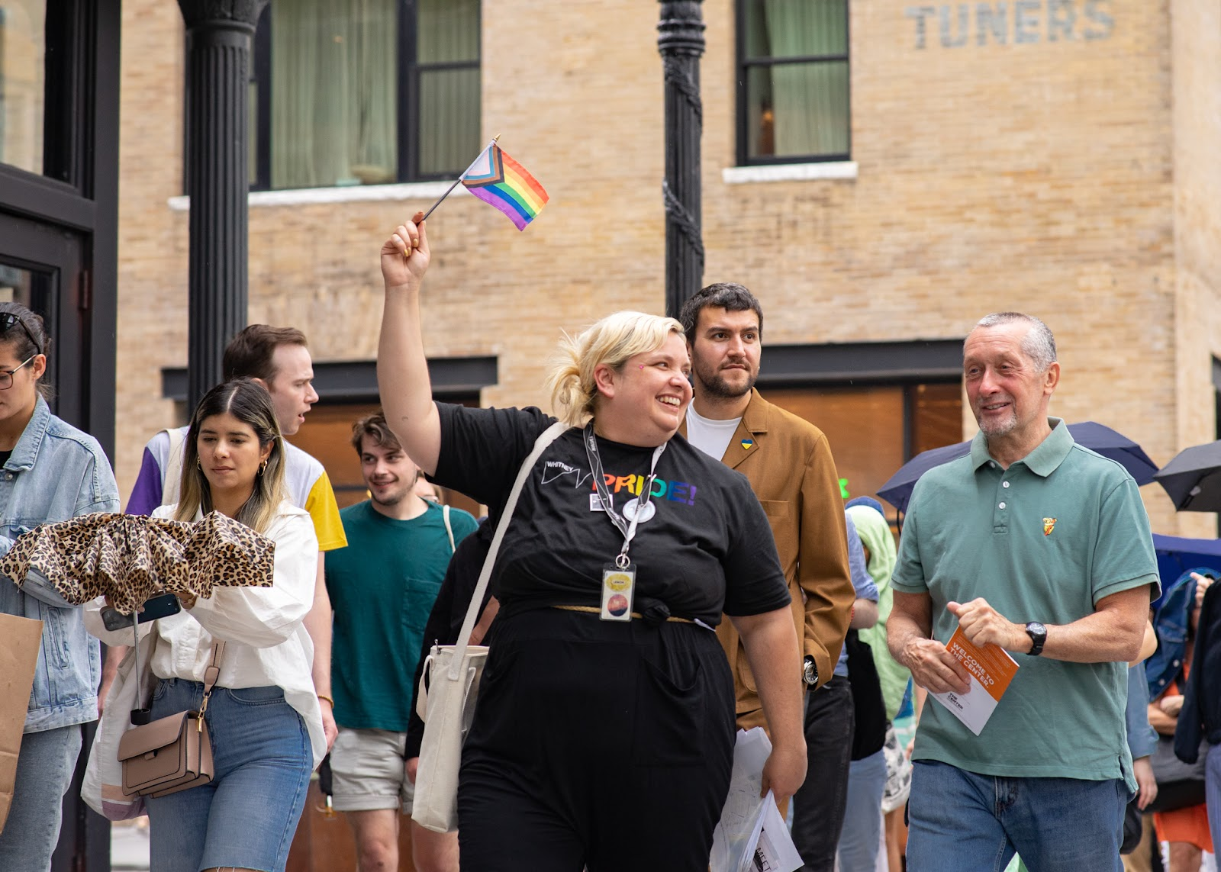

June

Whitney Pride Celebration Free Second Sunday
Sunday, June 8, 11 am–4 pm

Celebrate Pride at the Whitney with a series of programs dedicated to LGBTQ+ artists and communities and that offer an inclusive space for all to gather and enjoy American art. Enjoy artmaking, tours, and other special activities while also exploring the Whitney’s latest exhibitions. Admission to the Whitney is free all day on the second Sunday of every month for visitors of all ages. Free Second Sundays also includes free story times with The New York Public Library at 11 am, 1 pm, and 3 pm. Though admission is free, tickets are required, and capacity is limited.

Location: Whitney Museum
Tickets: Free; Tickets are still required, and capacity is limited. Advance booking is strongly recommended and can be reserved at whitney.org/admission.
Event Link: https://whitney.org/decade-downtown

Queer Teen Night with The Center
Friday, June 13, 4–7 pm

LGBTQ+ youth and allies are invited to celebrate Pride at the Whitney! Join the Museum’s Youth Insights Leaders, The Door’s Youth Council, and artist Dalton Gata for a night of artmaking, music, performances, dancing, giveaways, gallery tours, and a mini ball led by Haus of Us. This year’s event will highlight the powerful portraits in Amy Sherald: American Sublime and the dynamic group exhibition Shifting Landscapes, featuring artist Dalton Gata, who will lead a special artmaking experience. Come as you are, celebrate community, and make art in a space that uplifts queer joy!

Location: Whitney Museum
Tickets: Free, registration required.
Event Link: https://whitney.org/decade-downtown

Radical Joy Ball with ADAPT
Wednesday, June 18, 4–6 pm

Join the Whitney and our partner, ADAPT Community Network, for an evening celebrating inclusivity, access, and the pride of self-expression in the Museum’s theater. This event creates a space to celebrate the vibrancy of LGBTQ+ and disability pride through music, dance, and runway performances.

Location: Floor 3, Susan and John Hess Family Theater
Tickets: Free; guests can pick up tickets in the lobby. Seating is first come, first served.
Event Link: https://whitney.org/decade-downtown

New York City Gay Men’s Chorus at Free Friday Nights
Friday, June 27, 5–10 pm

Experience the vibrant heart of queer Pride with the New York City Gay Men’s Chorus at the Whitney! This event fills the entire Museum with the transformative power of song, featuring pop-up choral pieces that embody the spirit of Pride, joy, and community. Prepare to be moved and inspired by performances that surprise, uplift, and challenge, echoing through the halls of the Whitney.

This event coincides with Free Friday Nights, which offers free admission to the Museum.

Location: Whitney Museum
Tickets: Free; Tickets are still required, and capacity is limited. Advance booking is strongly recommended and can be reserved at whitney.org/admission.
Event Link: https://whitney.org/decade-downtown

Queer History Walks
Friday, June 6, 6 pm
Saturday, June 7, 4pm
Sunday, June 8, 4 pm
Friday, June 13, 6 pm
Saturday, June 14, 4pm
Sunday, June 15, 4 pm
Friday, June 20, 6 pm
Saturday, June 21, 4pm
Sunday, June 22, 4 pm
Friday, June 27, 6 pm
Saturday, June 28, 4pm
Sunday, June 29, 4pm

Join the Whitney education team on a Queer History Walk in the Meatpacking District to learn more about the impact and history of LGBTQ+ communities throughout the neighborhood surrounding the Museum. From the Hudson River piers to the clubs, visitors are invited to consider their connection to the changing landscape of the neighborhood that the Whitney now
occupies, as well as the city’s history. View the tour map.

Outdoor events are weather dependent and subject to cancellation or being moved indoors
should conditions require. Any changes to event plans will be noted online.

Location: Tours will meet outside the entrance of the Museum. The meeting place will be marked with physical signage.
Tickets: Free, registration required. Please note that Museum admission is not included.
Event Link: https://whitney.org/events/queer-history-walks-2025

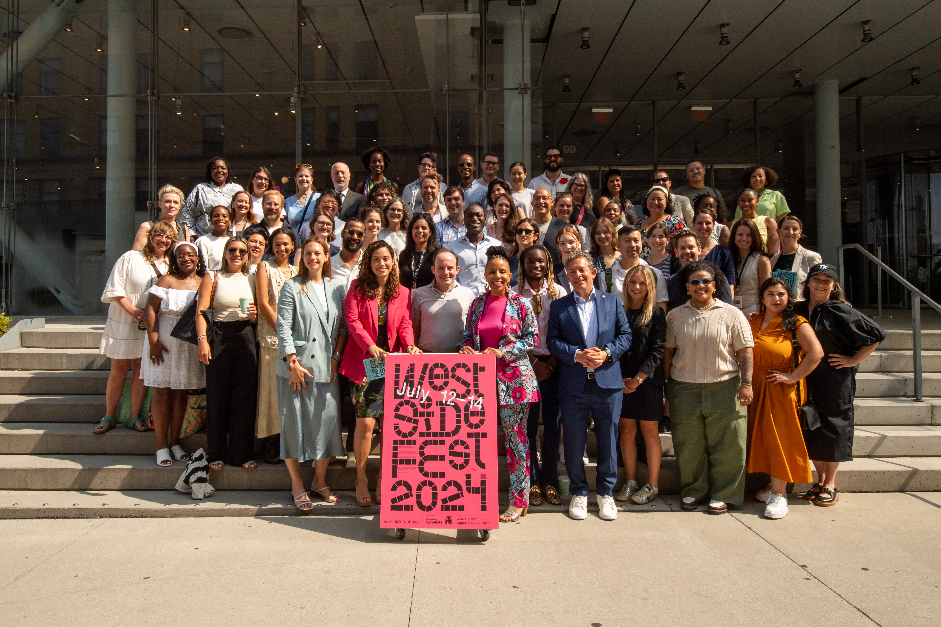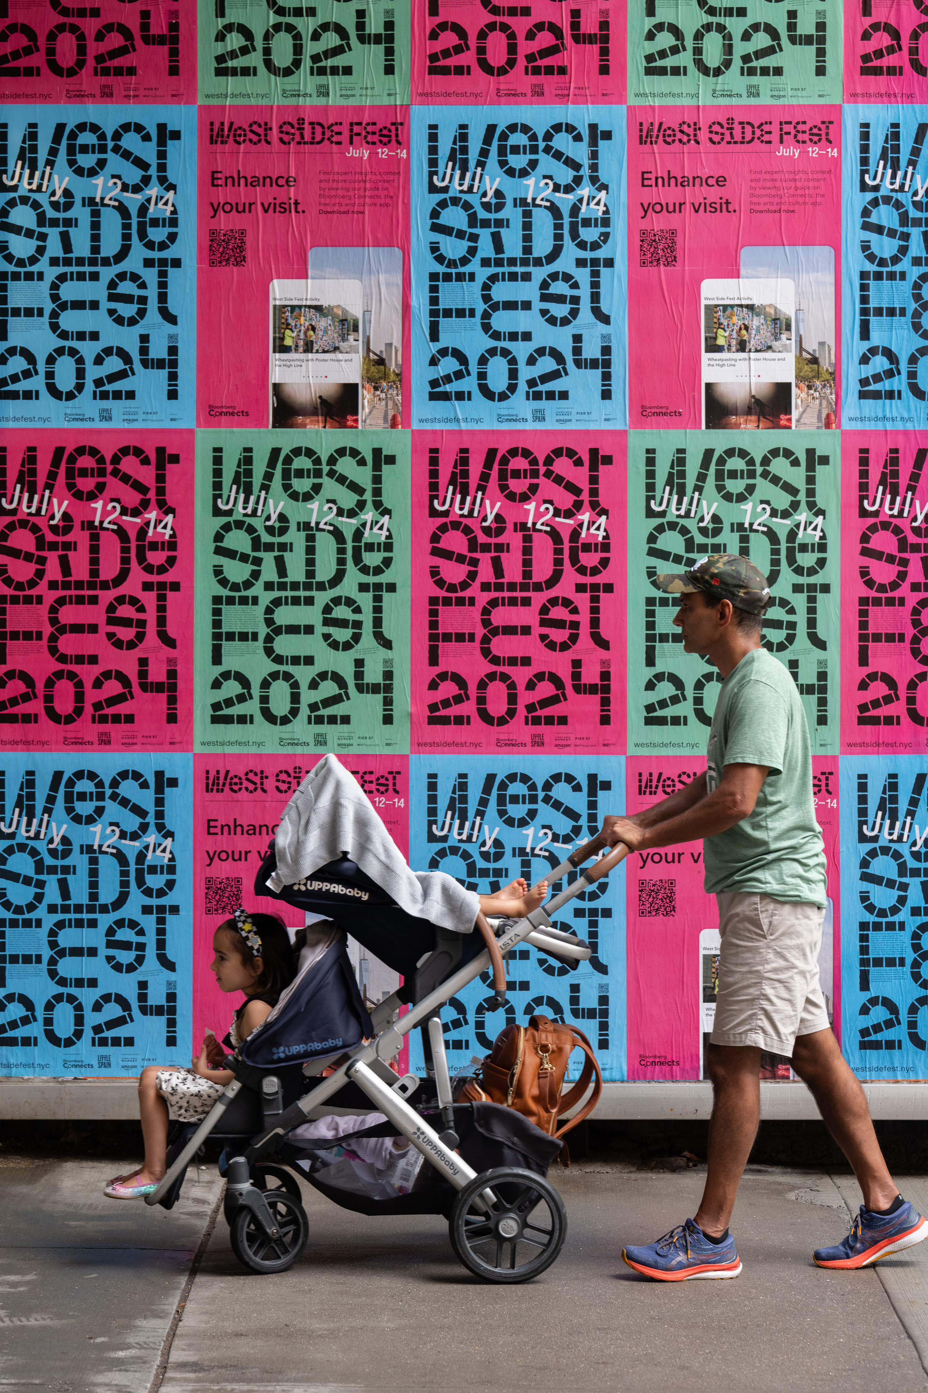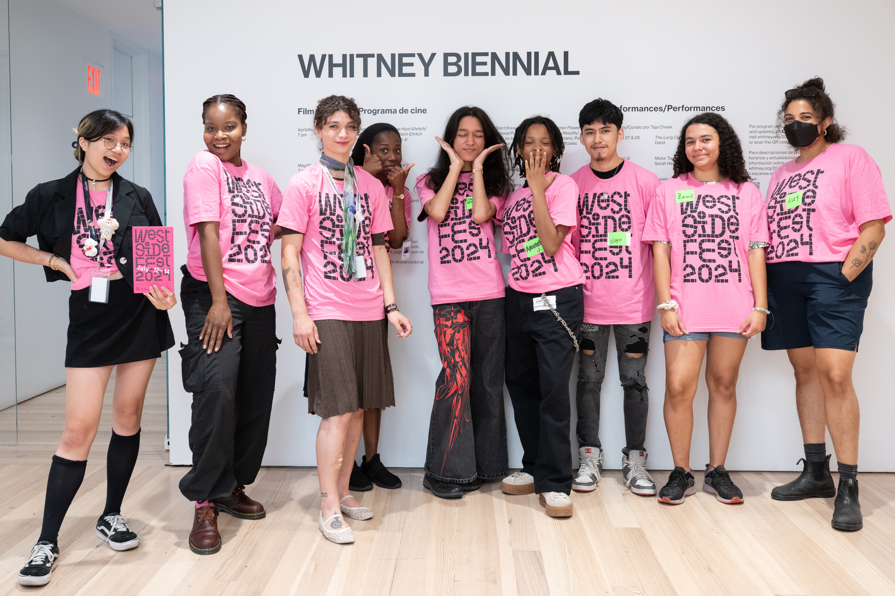

July

West Side Fest
July 11–13

Coinciding with the Whitney’s July Free Second Sunday and a Free Friday Night, West Side Fest returns July 11–13 for three days of festivities at the Whitney and organizations throughout the Meatpacking District and surrounding neighborhoods. New Yorkers and visitors of all ages are invited to celebrate the vibrant, cultural center along the waterfront of Manhattan’s west side with free admission, special indoor and outdoor programming, crafts for kids and families, artmaking activities for all ages, performances, and much more.

West Side Fest is organized by the West Side Cultural Network—a group of museums, parks, performing arts centers, and cultural institutions located within a half-mile portion of historic New York.

Location: Whitney Museum and surrounding neighborhoods
Tickets: Museum admission is free on select dates, and tickets are still required. Check whitney.org for program details.
Event Link: whitney.org/decade-downtown

PRESS CONTACT

For press materials and image requests, please visit whitney.org/press or contact:
Ashley Reese, Director of Communications
Whitney Museum of American Art
Ashley_Reese@whitney.org

Meghan Ferrucci, Publicist
Whitney Museum of American Art
Meghan_Ferrucci@whitney.org

Whitney Press Office
whitney.org/press
(212) 570-3633
pressoffice@whitney.org

ABOUT THE WHITNEY
The Whitney Museum of American Art, founded in 1930 by the artist and philanthropist Gertrude Vanderbilt Whitney (1875–1942), houses the foremost collection of American art from the twentieth and twenty-first centuries. Mrs. Whitney, an early and ardent supporter of modern American art, nurtured groundbreaking artists when audiences were still largely preoccupied with the Old Masters. From her vision arose the Whitney Museum of American Art, which has been championing the most innovative art of the United States for ninety years. The core of the Whitney’s mission is to collect, preserve, interpret, and exhibit American art of our time and serve a wide variety of audiences in celebration of the complexity and diversity of art and culture in the United States. Through this mission and a steadfast commitment to artists, the Whitney has long been a powerful force in support of modern and contemporary art and continues to help define what is innovative and influential in American art today.

Whitney Museum Land Acknowledgment
The Whitney is located in Lenapehoking, the ancestral homeland of the Lenape. The name Manhattan comes from their word Mannahatta, meaning “island of many hills.” The Museum’s current site is close to land that was a Lenape fishing and planting site called Sapponckanikan (“tobacco field”). The Whitney acknowledges the displacement of this region’s original inhabitants and the Lenape diaspora that exists today.
As a museum of American art in a city with vital and diverse communities of Indigenous people, the Whitney recognizes the historical exclusion of Indigenous artists from its collection and program. The Museum is committed to addressing these erasures and honoring the perspectives of Indigenous artists and communities as we work for a more equitable future. To read more about the Museum’s Land Acknowledgement, visit the Museum’s website.

VISITOR INFORMATION
The Whitney Museum of American Art is located at 99 Gansevoort Street between Washington and West Streets, New York City. Public hours are Monday, Wednesday, and Thursday, 10:30 am–6 pm; Friday, 10:30 am–10 pm; and Saturday and Sunday, 10:30 am–6 pm. Closed Tuesday. Visitors twenty-five years and under and Whitney members: FREE. The Museum offers FREE admission and special programming for visitors of all ages every Friday evening from 5–10 pm and on the second Sunday of every month.

Image credits:
Lead image: Free Second Sunday: Dancing in the Street, hosted by Maguette Camara, The Ailey School and Ailey Extension instructor, October 2024. Whitney Museum of American Art. Photograph by Filip Wolak
Left to right: Whitney Museum of American Art. Photograph by Nic Lehoux; Photograph by Matthew Carasella
Left to right: Photograph by Filip Wolak
Left to right: Photograph by Filip Wolak; Photograph by Summer Surgent-Gough
Left to right: Photograph by Christine Butler; Photograph by Filip Wolak

###

